PART 4: |  | DIFFERENT TIMES, DIFFERENT LOOKS

A Look at Things from the 1900s
Watch | 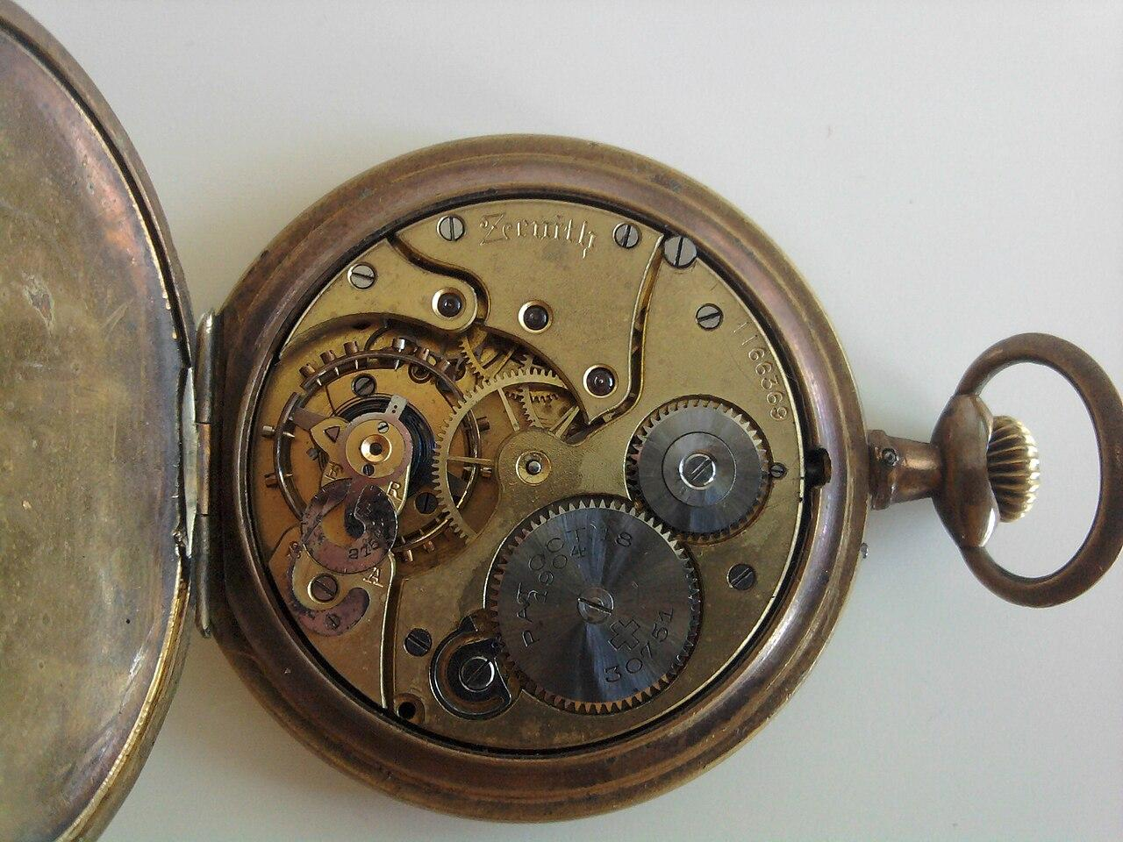
Looking Glass | 
Combs | 
Couch | 
Apartment | 
Men's Coat | 
Women's Hairstyle | 
Letter Box | 

Reflection Questions | Student Responses
How did the search for terms related to items and expenses from the year 1900 deepen your understanding of historical contexts and lifestyles during that time period? | Insert text
What similarities and differences did you notice between the items and expenses from 1900 and those commonly used or purchased today? | Insert text
What connections can you draw between the items and expenses researched from 1900 and the characters' lives in the story of Jim and Della? | Insert text

